Setup your Virtual Environment for Django

|  |  |  |
| --- | --- | --- |
|  | Commands |  |
| 1 | Open command prompt |  |
| 2 | cd\dev | Change folder to your development folder |
| 3 | mkdir *project_directory name* | Create a folder for your project |
| 4 | cd *project_directory_name* | Change folder to your project folder name |
| 5 | py -m venv venv | Creates virtual environment. Usually create within your project. Creates a folder in the directory you are currently in. |
| 6 | venv\Scripts\activate.bat | Activates the environment |
| 7 | py -m pip install Django pip install Django | Install Django in your project Installing various packages to your project |
| 8 | pip freeze | This is optional. |
| 9 | django-admin startproject *name_of_project* . |  |
| 10 | python manage.py startapp *name_of_app* | This creates an app within the project |
| 11 | python manage.py runserver | This will spin up sqllite.db |

Your first app component – working with models

|  |  |  |
| --- | --- | --- |
|  | Instructions |  |
| 1 | python manage.py startapp *name_of_app* | This creates an app within the project |
| 2 | Open the settings file and add an entry to the INSTALLED_APPS | Enter the new app that you created from step 1 |
| 3 | Enter your class models in models.py | Create your various tables |
| 4 | python manage.py makemigrations | Run every time you change models |
| 5 | python manage.py migrate | Run every time you change models |
| 6 | Edit admin.py to import your apps  admin.site.register(*name of class*) | This will allow you to edit the tables that you created |
| 7 | python manage.py createsuperuser | Creates a user for the admin panel |

git clone <https://github.com/mdomeracki231994/website.git>

[Django Tutorial #6 - Django Models - YouTube](https://www.youtube.com/watch?v=5zNR3E6WRLE)

[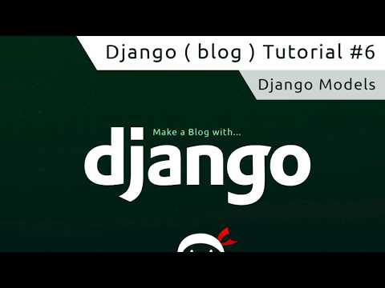](https://www.youtube.com/watch?v=5zNR3E6WRLE)

[Django Tutorial #7 - Migrations - YouTube](https://www.youtube.com/watch?v=aOLrEkpGWDg)

[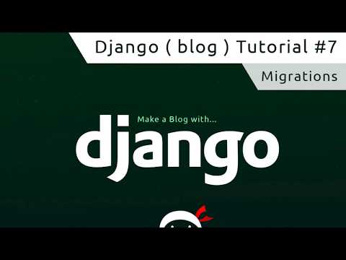](https://www.youtube.com/watch?v=aOLrEkpGWDg)